Concept:
Player is escaping a mental hospital
Game starts with elevator door opening
Making way through mental hospital whilst they hallucinate the environment changing and disappearing/reappearing
Doctors turn into monsters then back again
Rooms with certain features eg rainbow room contrasting, music leads players to it
Player is in a wheelchair, user needs to use controllers to wheel themselves around
Get from elevator to exit
Ending:
- Player escapes
- Player wheels off edge of map – leans into insanity?
- Doctors capture player

Mechanics:
Doctors only move when player is looking at them
Environment disappears behind player so when they look around its gone

Art Design:
- Lab
- Grey
- White
- Black
- rainbow
- chromatic aberration at times?
- Fog?
- ALL OF THIS CAN CHANGE AT ANY POINT IN THE GAME, ITS IN THE PLAYERS MIND!

Monster design:
- Speak English reversed and slowed down
- Only move when not looking at them, come after player
- Different designs?
- Monster based off of a doctor -> stethoscope etc
- Don’t be completely still, be vibrating slightly when in place

Names:
- Mental hospital related
- Escaping
- Insanity
- Names:
  - Lunacy
  - Instability
  - Delirium
  - Yeah idk

Notes:
- Needs to be easily picked up by people walking by – can do this with immediate mechanics not just relying on slow narrative scaling idea would work for this but doesn’t fit with narrative
- We can do literally anything we want as long as we format it under the guise of hallucination
- Need to make sure the setting isn’t too uninteresting – divert common horror tropes, almost make the player feel safe at first with lighting lack of fog until mental state takes over ceiling and floor visible at first but as levels change and settings disappear its got black fog makes player uneasy

Images:
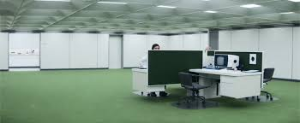
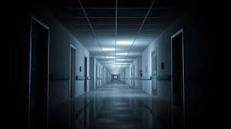
Start of game

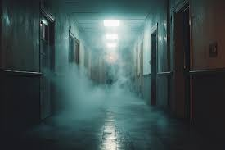
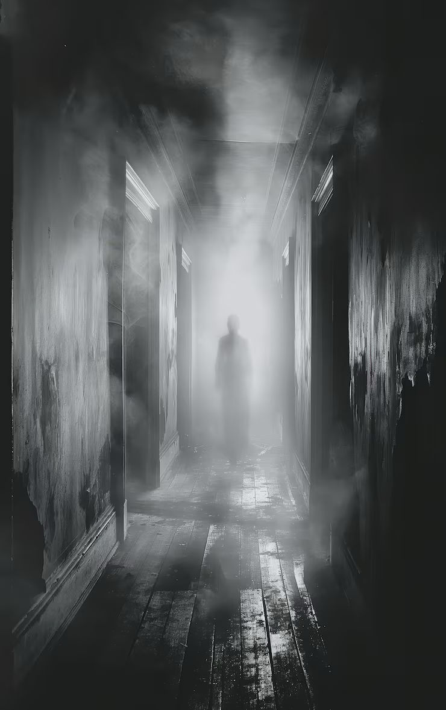
End of game

